CSA1701-ARTIFICIAL INTELLIGENCE

NAME:P HARISH
REG NO:192524197

Water Jug Problem –Lab Experiment
Aim:
To write a Python program to solve the Water Jug Problem using the Breadth First Search (BFS) algorithm.
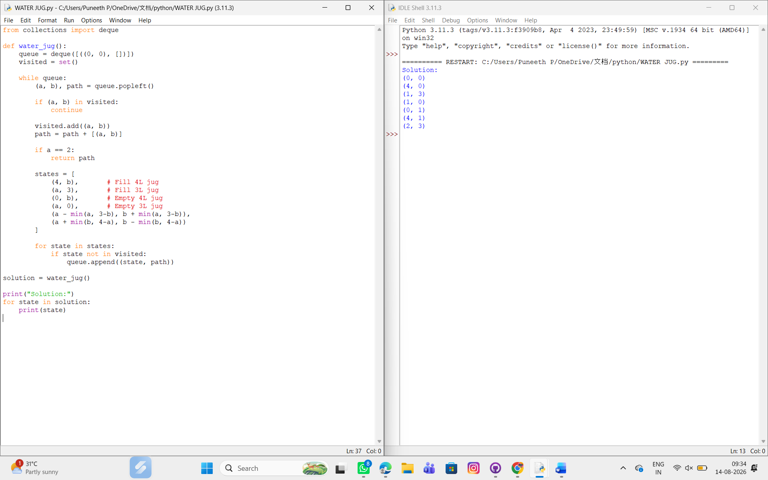
Result
Thus, the Water Jug Problem was successfully solved using the BFS algorithm in Python, and exactly 2 liters were obtained in the 4-liter jug.

